**Ex. 4.** **Webpage design using Advanced CSS3**

**URK17CS127**

**Date:**

1. Create a web page using proper HTML5 and CSS3.
2. Set a fixed header with logo at the left side and fixed navigation bar next to it. Set gradient background to the header that starts from the top/bottom.
3. For eg: background: linear-gradient(to right, rgba(0,0,255,0), rgba(0,0,255,1)); 2. Banner a. Add a banner image, header and navigation bar should be placed over it. b. Display three divisions over the image and position them using position and offset properties. Design the banner as per the mock-up. c. Give hovering and change the background when the cursor is placed over the image. d. Display a fixed advertisement at the right side of the banner. e. Display the vision of our university as in the mockup page. 3. After the banner add a sections. Inside the section float the image at the right side and warp the text around it. Give separate background color for inside and outside of the section. 4. Finally end with a footer at the bottom as in mock up page.
4. Here is the mockup illustration of the site. Your final result should look very close to this mockup. Use the mockup illustration page given in courses.karunya.edu. Your final result should look very close to the mockup.
5. Publish your website live on web using any free web hosting services (000webhost)

Refer the mockup illustration of the site given in courses. Your final result should look very close to this mockup.

**Mockup Page:**

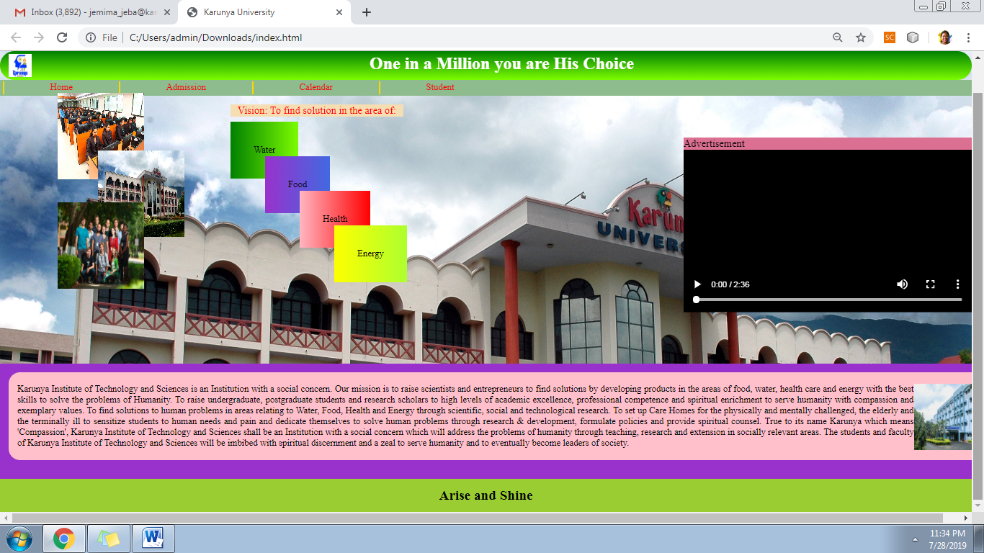

**Web site URL:** <http://urk17cs127.rf.gd/Exercise4/>

**You tube URL:** [**https://youtu.be/wc1KIBijor0**](https://youtu.be/wc1KIBijor0)